SOUTHAMPTON
HOCKEY

Come and play Junior Hockey on Sunday mornings with training from 2nd September through to 28th April 2019, from 9.00am to 10.30am. Home matches will be played at Southampton Sports Centre (SO16 7AY), between 10.45am and 12 noon.

Sessions will be run by SHC experienced coaches for players aged from 5 years to 14 years from 9.00am to 10.30am. Boys and girls of all abilities are welcome.

Further training for 9 years to 13 years upwards is available on Tuesday evenings 6.00pm to 7.30pm.

Players 13 to 18 years train on Thursday evenings from 6.00pm to 7.30pm.

Men (13+) train on Monday evenings from 7.00pm to 9.30pm.

Ladies (13+) train on Tuesday evenings from 7.30pm to 9.00pm.

We can supply:
- sticks and balls (gum shield and shin guards are recommended)
- three weeks of free hockey coaching in September
- the opportunity to join a family Hockey Club

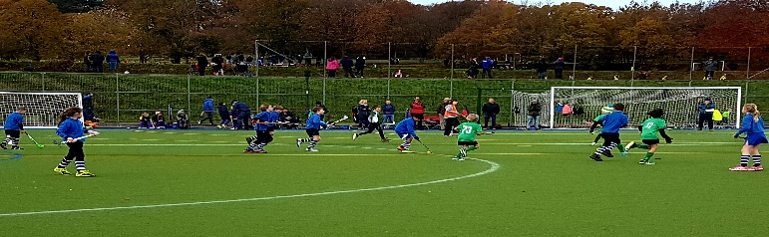

Please contact Sue Merry ( 02380 735737 or juniors@southamptonhc.org)

